**Intro to Csharp**

using System called as namespace declaration which states that we will use class and methods from this name spaces. It is way to organize your code and reuse it in different project. it is collection of class, structs, Enums, delegates and interfaces. it may include other namespaces too.

Main method is the entry point of the program.

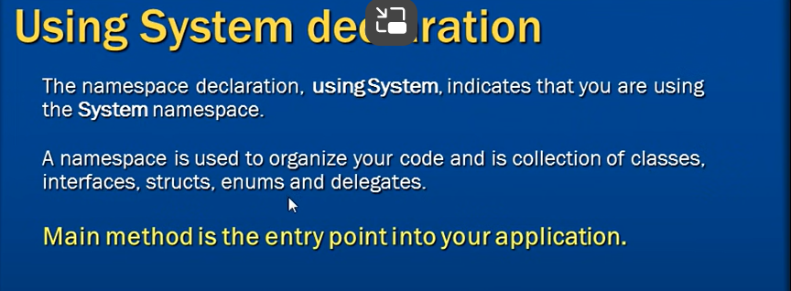

**Reading and writing to Console.**

